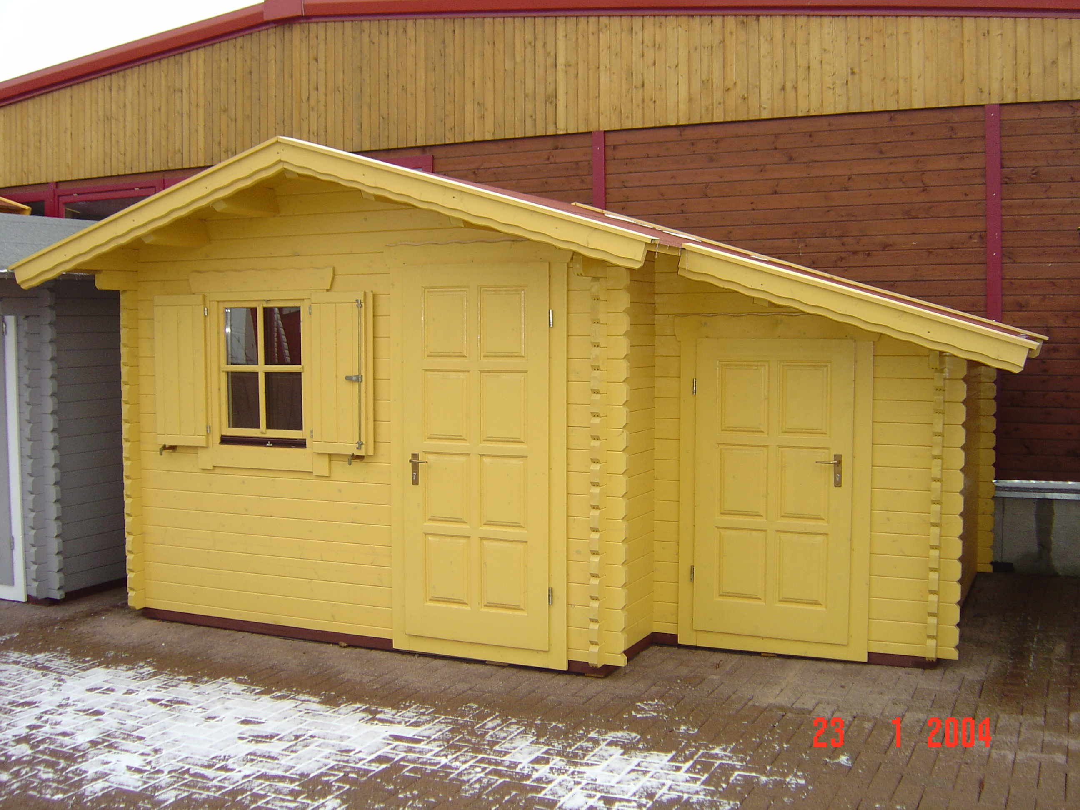 | 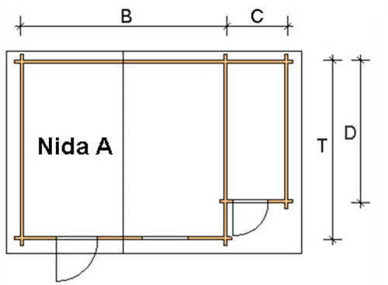
 | 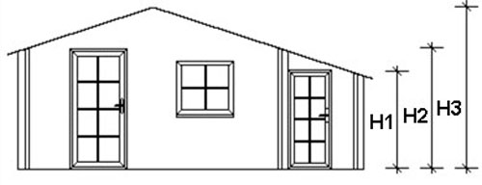

Nida-A Log Cabin
Roof projection: Front 0.70 m
Back 0.20 m
Side 0.30 m

Consists of:
Walls: 45 mm or (60 mm glued) double tongue and groove
Floor: 20 mm tongue and groove floor boards on the impregnated base frame
Roof: 20 mm tongue and groove roof boards
Door: 1 glued cartridge door 90/196 with seal
Windows: 1 double-glazed 80/94 tilt ‘n‘ turn unit

Size (m) |  |  |  | Log Cabin Height (m) |  |  | Price (£) |  | Optional Extras
 |  |  |  |  |  |  |  |  | Roof Insulation (£) |  | Shingles (£)
B | T | C | D | H1 | H2 | H3 | 45 | 60 | 45 | 60 | Shingles (£)
3 | 3 | 1.5 | 2.3 | 1.67 | 2.08 | 2.5 | 2658 | - | 121 | - | 146
3 | 4 | 1.5 | 3.3 | 1.67 | 2.08 | 2.5 | 3157 | - | 145 | - | 170
4 | 3 | 1.5 | 2.3 | 1.67 | 2.08 | 2.63 | 3031 | - | 145 | - | 170
4 | 4 | 1.5 | 3.3 | 1.67 | 2.08 | 2.63 | 3550 | 4462 | 174 | 177 | 170
4 | 5 | 1.5 | 4.3 | 1.67 | 2.08 | 2.63 | 3884 | 4875 | 197 | 200 | 243
5 | 4 | 1.5 | 3.3 | 1.67 | 2.08 | 2.63 | 3899 | 4675 | 204 | 206 | 243
5 | 5 | 1.5 | 4.3 | 1.67 | 2.08 | 2.63 | 4262 | 5433 | 230 | 232 | 275

Extras:

Single window £83
Double window 1200/940 £124
Single door £159
Double door 1700/1970 £267

